ASSIGNMMET ON LAMBDA EXPRESSION

1. Write an application to perform basic arithmetic operations like add, subtract, multiply & divide. You need to define a functional interface first.

Description:-

Define Functional Interface and write a program to perform arithmetic operations like add, subtract, multiply and divide using functional interface.

Examples:

              Input:-          13       5

              Output:-

                                      18.0      //Addition of 13 and 5

                                       8.0        //Subtraction of 13 and 5

                                       65.0      // Multiplication of 13 and 5

                                       2.6        //Division of 13 and 5

FunctionalInterface:-

A functional interface is an interface that contains only one abstract method. They can have only one functionality to exhibit. From Java 8 onwards, lambda expressions can be used to represent the instance of a functional interface. A functional interface can have any number of default methods. Runnable, ActionListener, Comparable are some of the examples of functional interfaces.

**Code:**

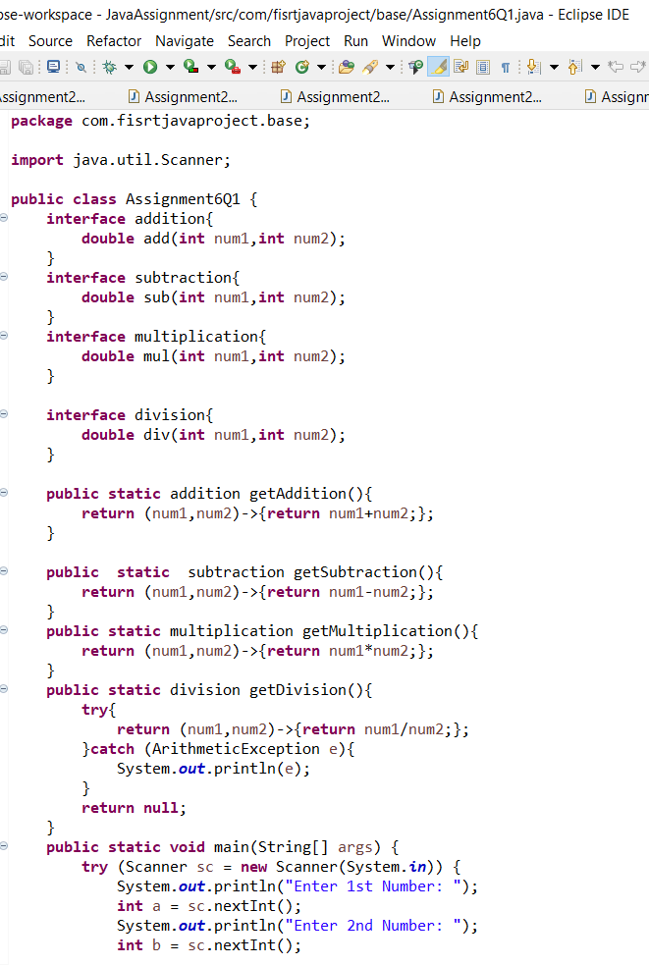

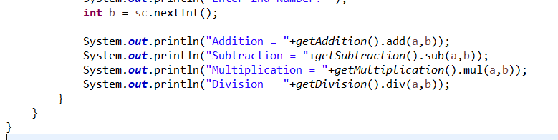

**Output:**

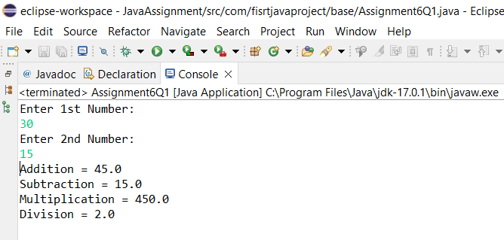

Q2. Write an application using lambda expressions to print Orders having 2 criteria implemented: 1) order price more than 10000 2) order status is ACCEPTED or COMPLETED.

Description:

Write a program in such a way that it has a method which returns the list of orders satisfying the 2 conditions mentioned in the question.

**Code:**

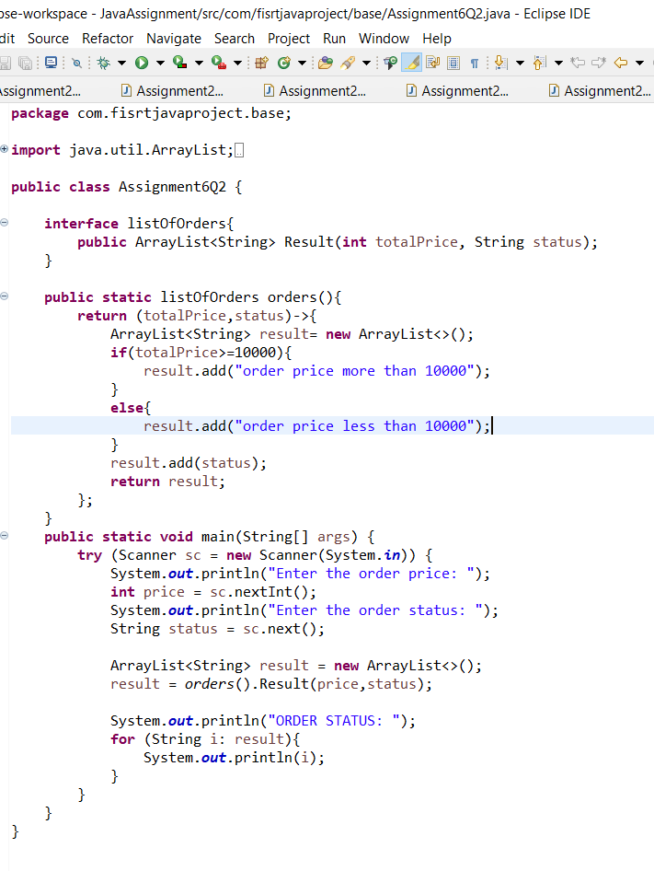

**OUTPUT:**

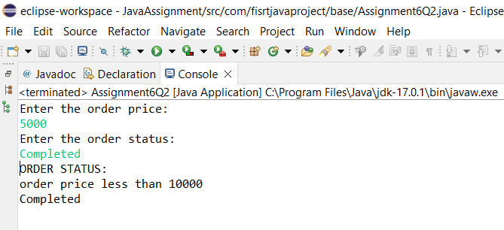

Q4. Remove the words that have odd lengths from the list. HINT: Use one of the new methods from JDK 8. Use removeIf() method from Collection interface.

Description:-

**Code:**

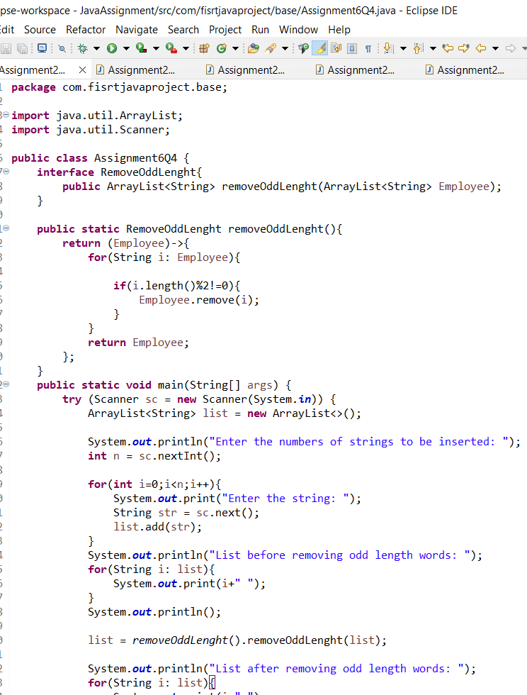

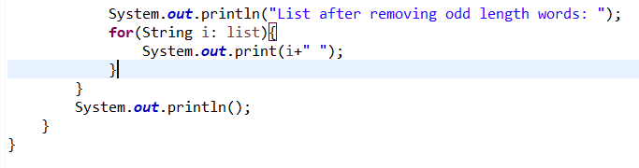

**Output:**

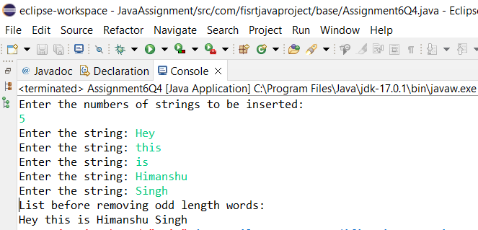

Q5. Create a string that consists of the first letter of each word in the list of Strings provided. HINT: Use Consumer interface & a String Builder to construct the result.

Description:

Write a java program using StringBuilder and Consumer interface which will return a string. The returned string should consistes of the first let of each word in the list of words.

**Code:**

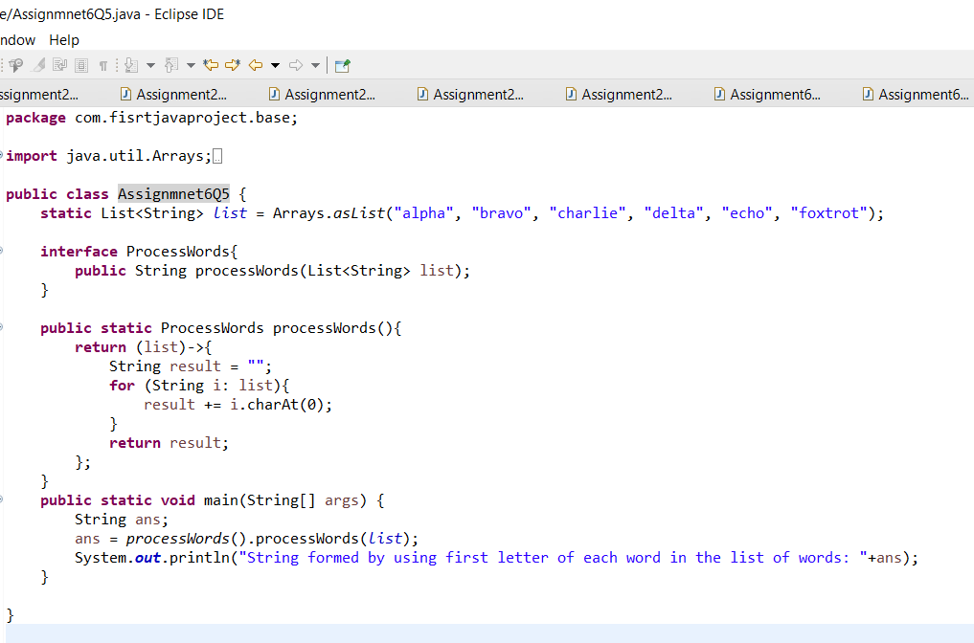

**Output:**

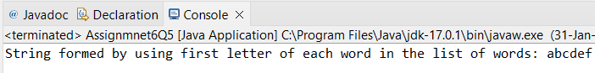

6. Replace every word in the list with its upper case equivalent. Use replaceAll() method & Unary Operator interface.

Using replaceAll() method and Unary Operator interface write a java program which replaces evry word in the list with its upper case equivalent.

**Code:**

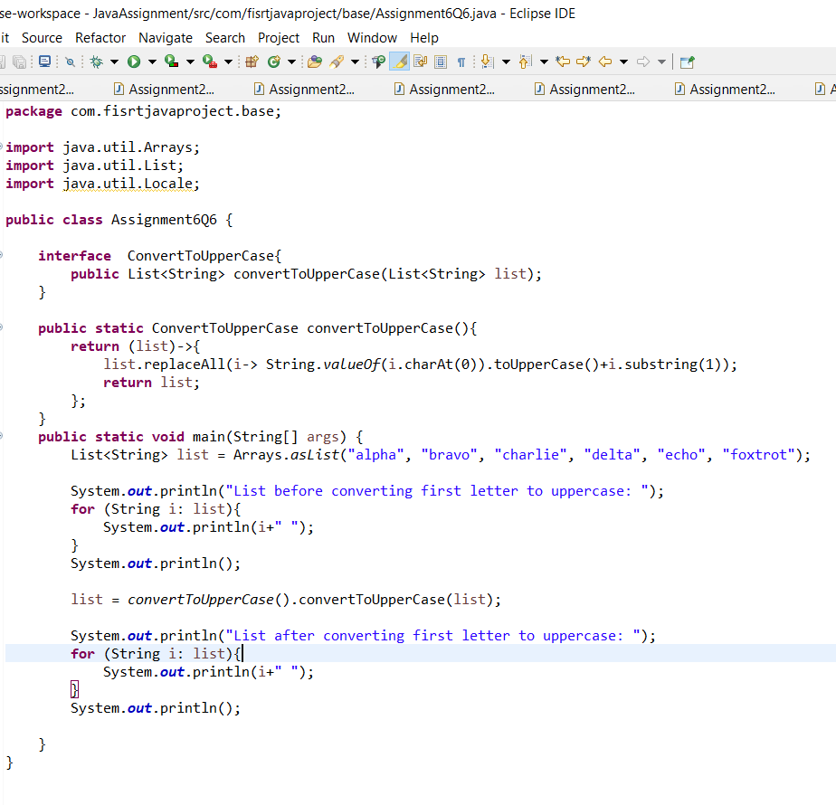

**Output:**

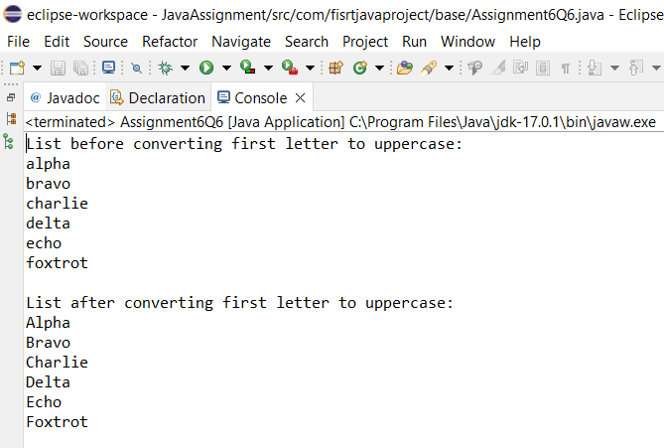

7. Convert every key-value pair of the map into a string and append them all into a single string, in iteration order. HINT: Use Map.entrySet() method & a StringBuilder to construct the result String.

Description:-

Write a java program using Map.entrySet() method & a StringBuilder which will return a string by appending all the key value pairs of a map into a single string ,in insertion order.

**Code:**

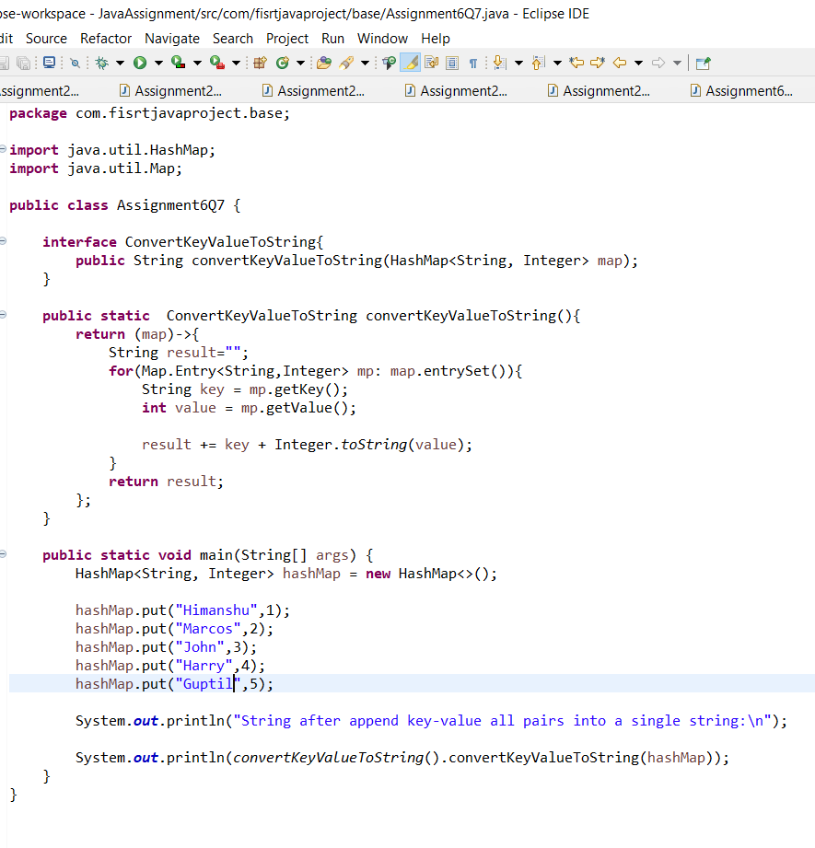

**Output**:

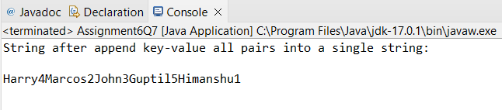

Q8. Create a new thread that prints the numbers from the list. Use class Thread & interface Consumer.

Description:-

Write a java program which will print the list of number using Thread and interface Consumer.

**Code:**

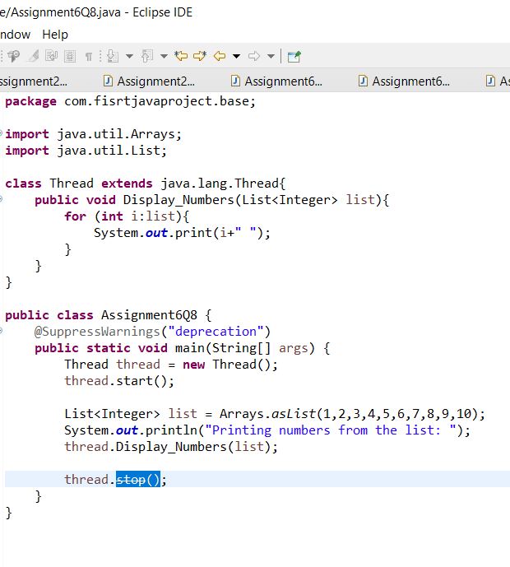

**Output:**

